**PSSA Dunford Cup GALA Day**

Please set up your school’s gazebos in one of the allocated red zones below. Please make sure to find Jonathon Hicks upon arrival to sign your school in via the sign on sheet.

Please take note at the field numbers to ensure your teams are prompt and ready for their games due to time restrictions and so your school knows what goals they are putting away. Thank you!

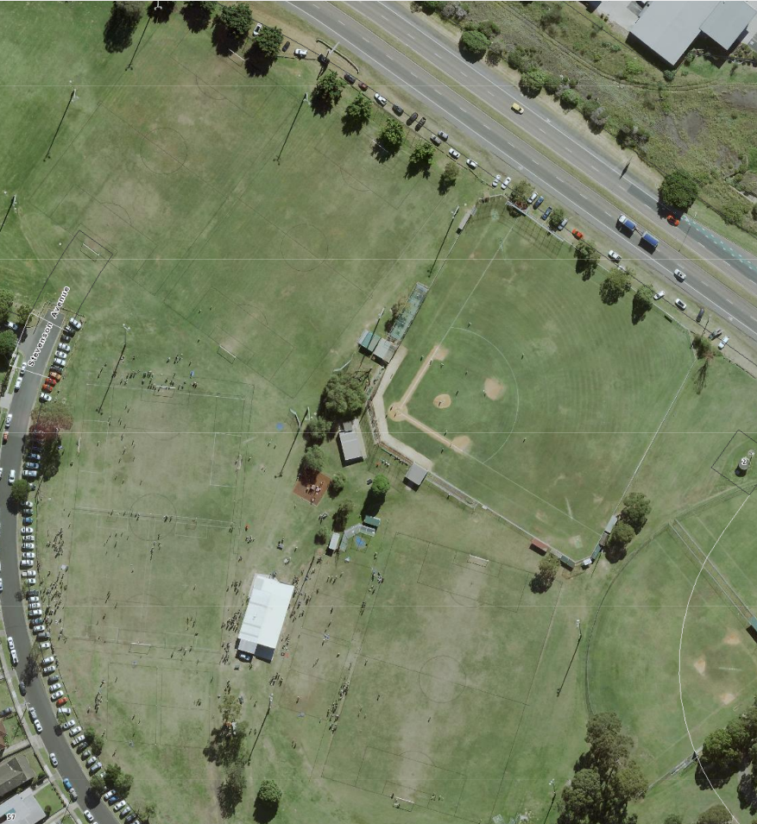

44

3

2

1